**GOVERNMENT COLLEGE OF ENGINEERING [IRTT]**

**ERODE: 638 316**



**Electronics and Communication Engineering**

**NAAN MUDHALVAN**

**DIGITAL MARKETING**

**ASSIGNMENT**

NM ID: F756DDC3FFAD52BB1F34B346F2085540

NAME: SANJAY V

*BRAND NAME: HI5MOBILES*

*CATEGORY: ELECTRONICS*

1. Create a blog or website using Blogspot and WordPress. Customize the theme design and post new article with 500 words.

Link: Blog using Blogspot

<https://hi5mobilesandgadget.blogspot.com/>

Screenshot:

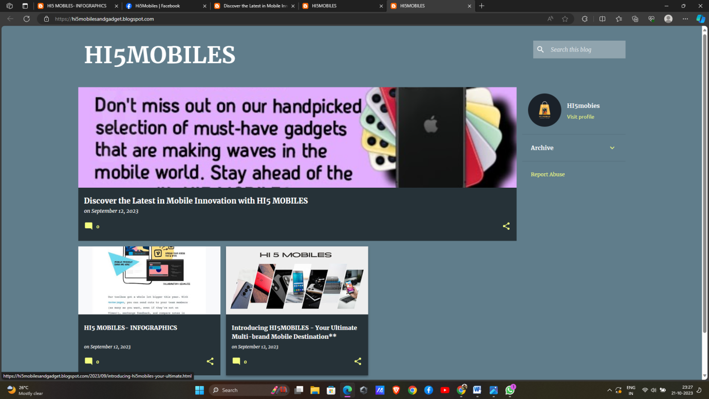

2.Create a New Facebook Business Page and post one social media poster for your brand.

Link: Facebook business page

https://www.facebook.com/profile.php?id=61551125701438

Screen shot:

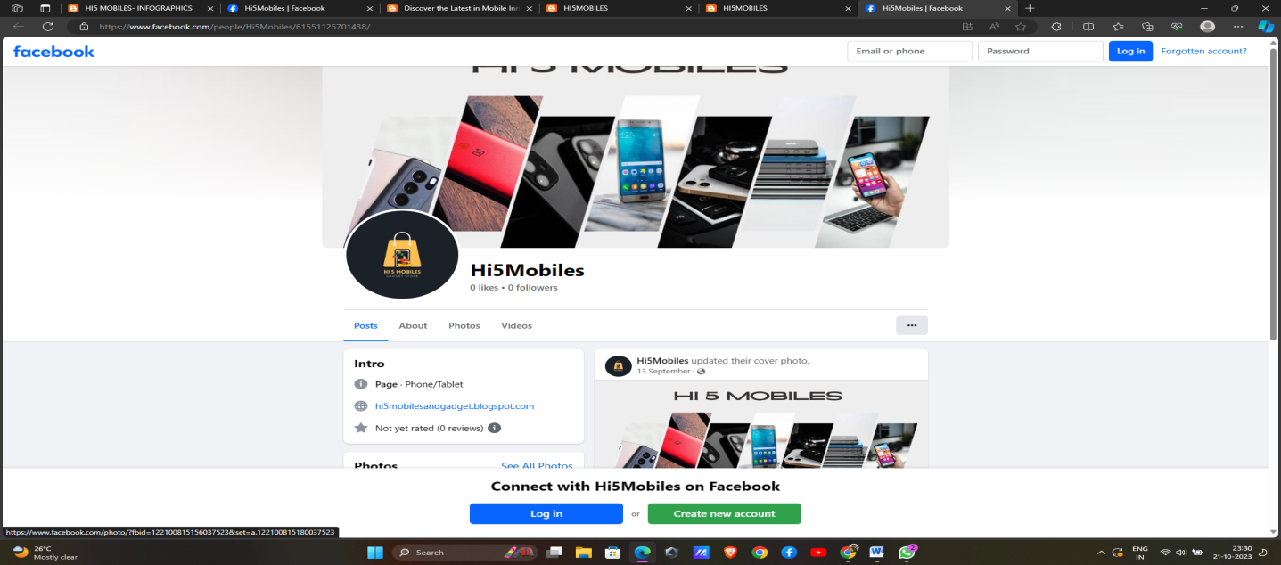

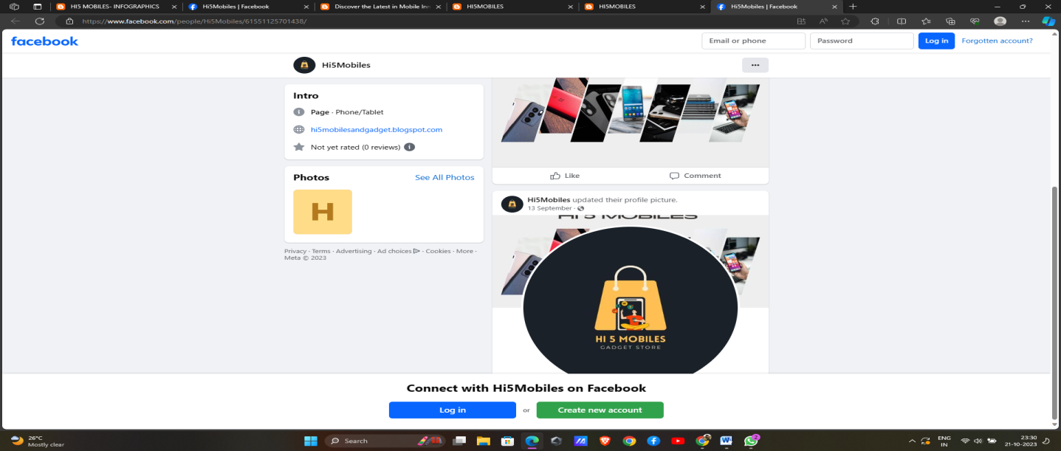

3.Create and design a social media advertisement poster using canva.

Link:

<https://hi5mobilesandgadget.blogspot.com/2023/09/discover-latest-in-mobile-innovation.html>

Screenshot: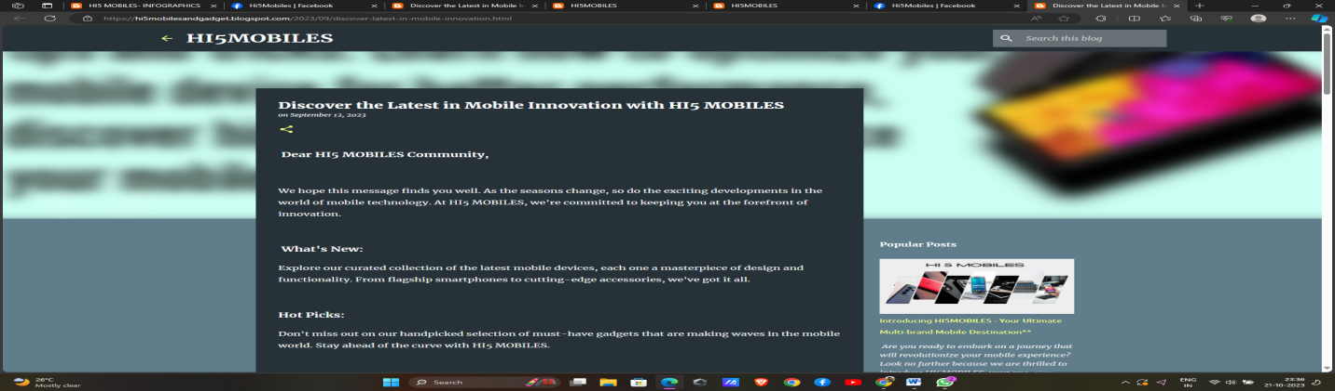

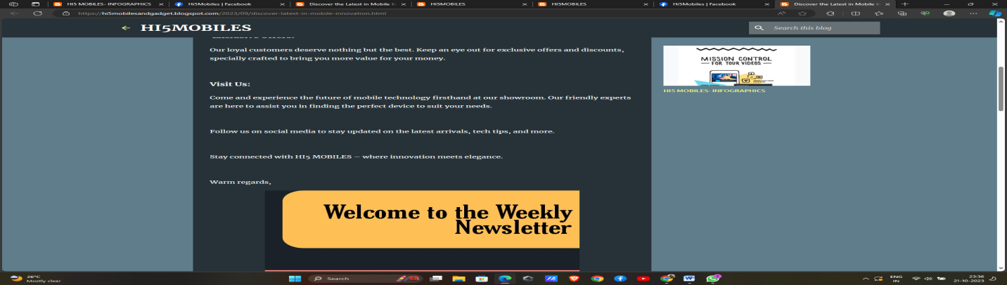

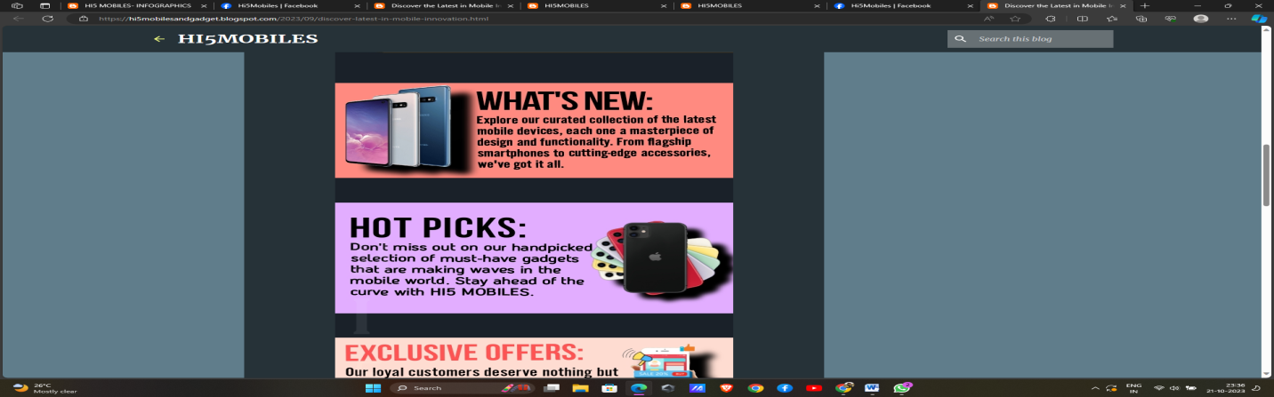

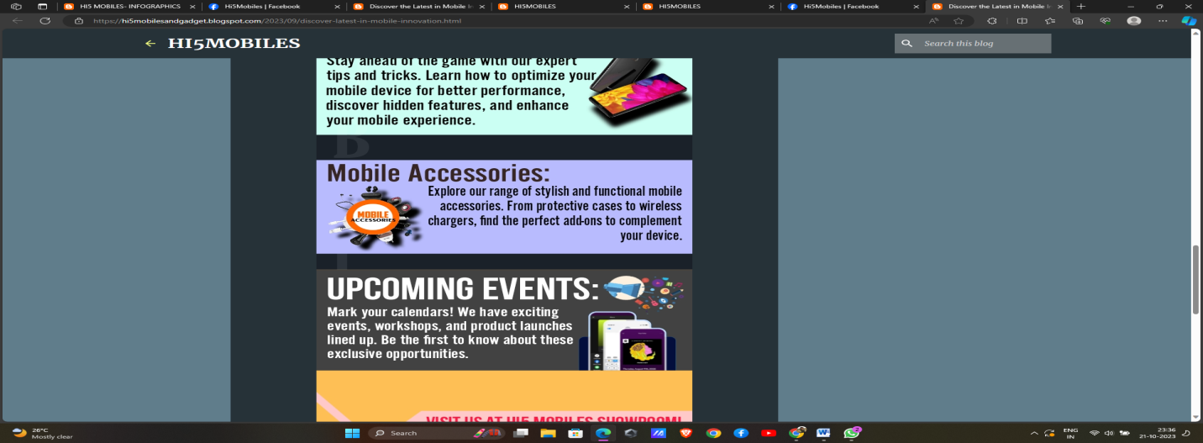

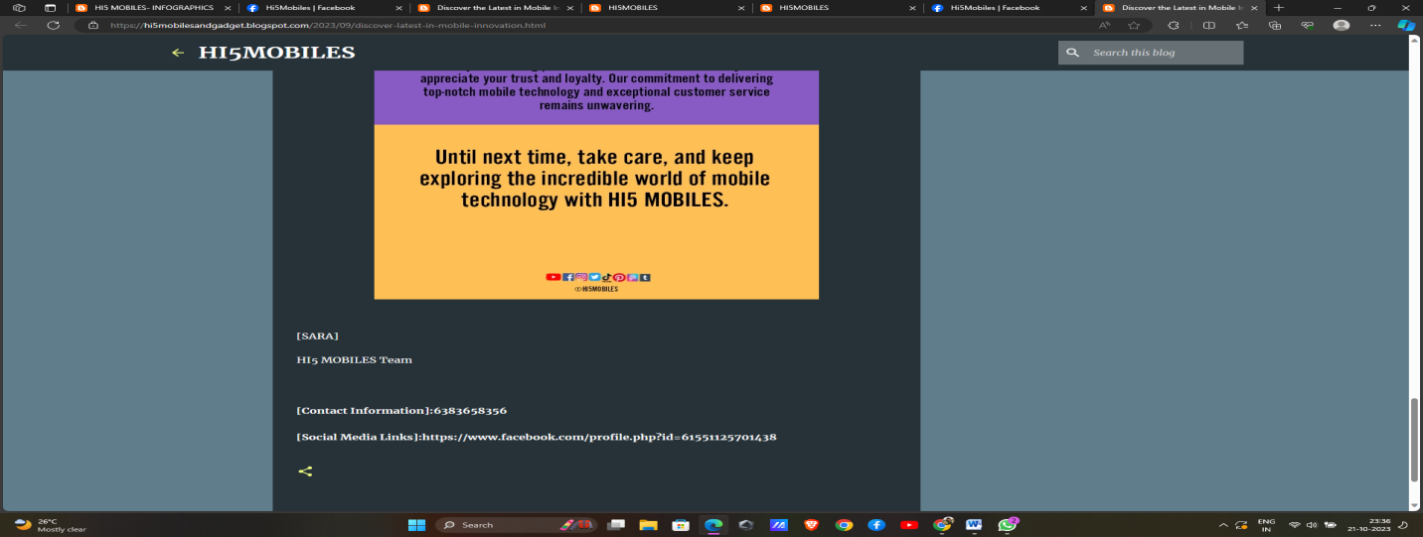

4.Create email newsletter design using MailChimp or canva tool.

Link: Email newsletter design using canva

<https://hi5mobilesandgadget.blogspot.com/2023/09/hi5-mobiles-infographics.html>

screen shot:

